1. **Provide a screenshot to show that you successfully created the mongoDBCreate.py file in VS Code.**

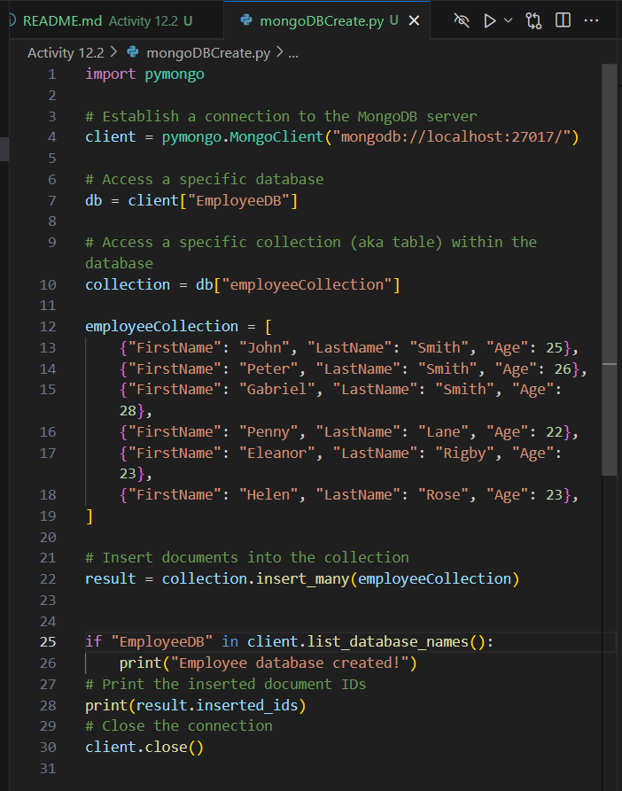

1. **Provide a screenshot of the output from mongoDBCreate.py to show that the database has been created (“Employee database created!”). This screenshot should also show that MongoDB returned the ObjectIds of each of the employees created.**



1. **Provide a screenshot to show that you successfully created the mongoDBFindOne.py file in VS Code.**

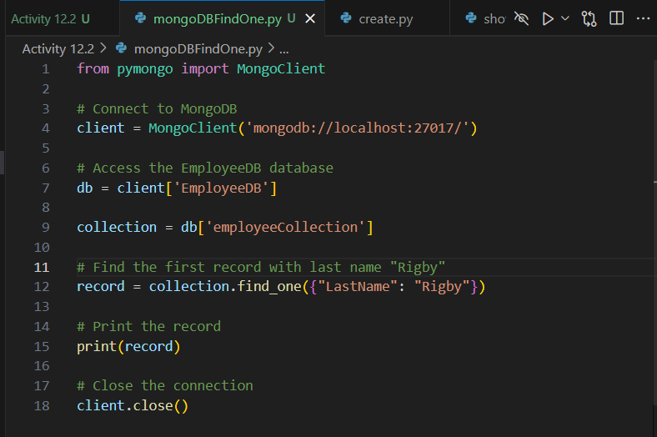

1. **Provide a screenshot to show the output of the print *statement* with the returned employee with last name of “Rigby”.**



1. **Provide a screenshot to show that you successfully created the mongoDBFindMany.py file in VS Code.**

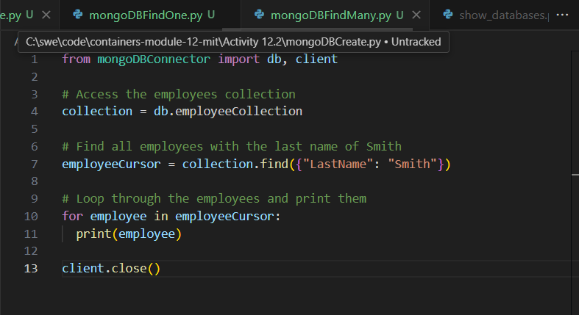

1. **Provide a screenshot to show the output of the code that displays three employees with the last name “Smith”.**

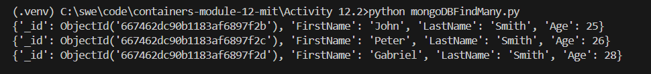

1. **Provide a screenshot to show that you successfully created the mongoDBUpdateOne.py file in VS Code.**

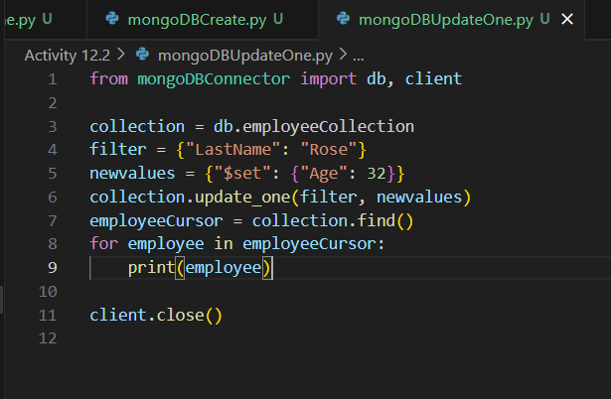

1. **Provide a screenshot to show the output of the code that displays the employee “Helen Rose” showing Age = 32.**

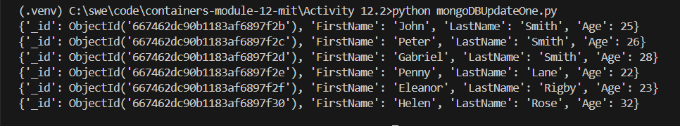

1. **Provide a screenshot to show that you successfully created the mongoDBUpdateMany.py file in VS Code.**

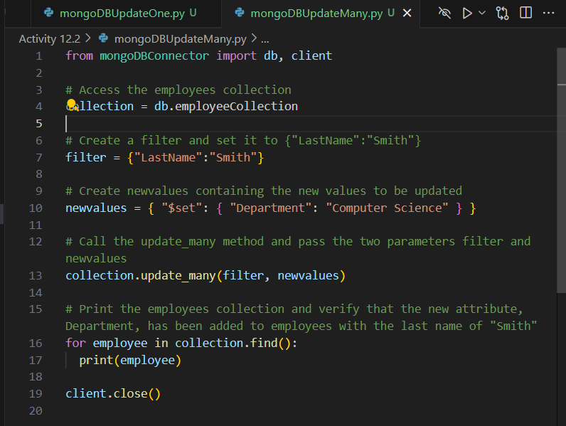

1. **Provide a screenshot to show the output of the code, which should display all employees and the employees with the last name of “Smith” should have a new *attribute* named Department with a value of Computer Science.**

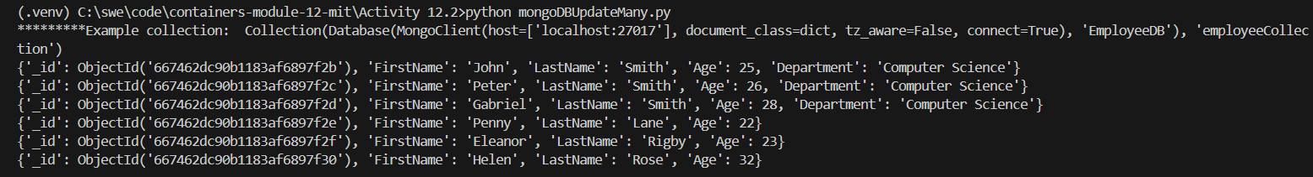

1. **Provide a screenshot to show that you successfully created the mongoDBDeleteOne.py file in VS Code.**

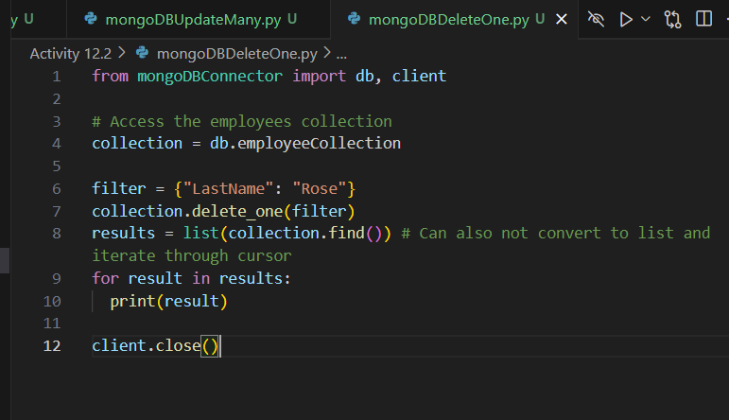

1. **Provide a screenshot to show that the employee with the last name of “Rose” has been deleted.**

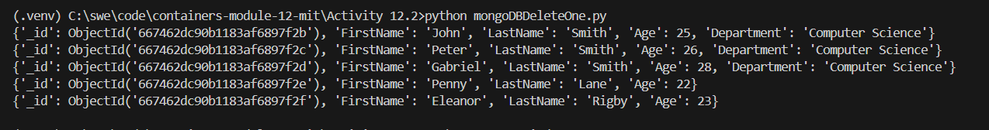

1. **Provide a screenshot to show that you successfully created the mongoDBDeleteMany.py file in VS Code.**

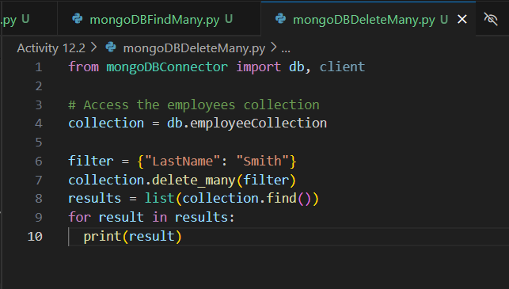

1. **Provide a screenshot to show that the employees with the last name of “Smith” have been deleted.**

